**1.2 TestDemo (Android File)**

**Activity_main.xml**

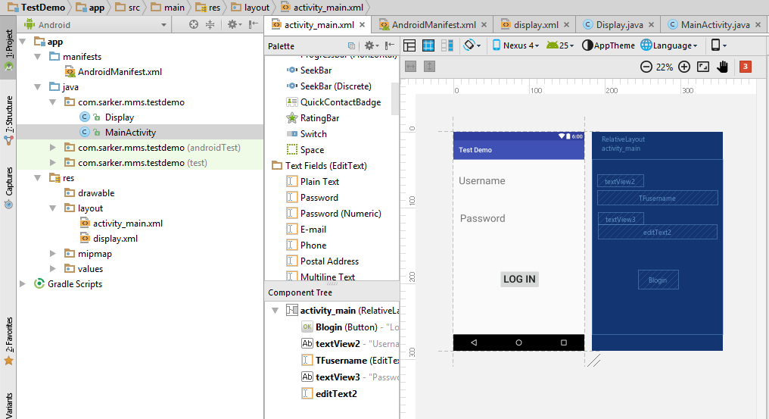

*<?***xml version="1.0" encoding="utf-8"***?>*<**RelativeLayoutxmlns:android="http://schemas.android.com/apk/res/android"  
xmlns:tools="http://schemas.android.com/tools"  
android:id="@+id/activity_main"  
android:layout_width="match_parent"  
android:layout_height="match_parent"  
android:paddingBottom="@dimen/activity_vertical_margin"  
android:paddingLeft="@dimen/activity_horizontal_margin"  
android:paddingRight="@dimen/activity_horizontal_margin"  
android:paddingTop="@dimen/activity_vertical_margin"  
tools:context="com.sarker.mms.testdemo.MainActivity"**>  
  
<**Button  
android:text="Log In"  
android:textSize="30sp"  
android:layout_width="wrap_content"  
android:layout_height="wrap_content"  
android:id="@+id/Blogin"  
android:layout_marginLeft="119dp"  
android:layout_marginStart="119dp"  
android:layout_marginBottom="118dp"  
android:layout_alignParentBottom="true"  
android:layout_alignParentLeft="true"  
android:layout_alignParentStart="true"  
android:onClick="onButtonClick"** />

<**TextView  
android:text="Username"  
android:layout_width="wrap_content"  
android:layout_height="wrap_content"  
android:layout_alignParentTop="true"  
android:layout_alignParentLeft="true"  
android:layout_alignParentStart="true"  
android:layout_marginTop="28dp"  
android:id="@+id/textView2"** />  
  
<**EditText  
android:layout_width="match_parent"  
android:layout_height="wrap_content"  
android:inputType="textPersonName"  
android:ems="20"  
android:layout_below="@+id/textView2"  
android:layout_alignParentLeft="true"  
android:layout_alignParentStart="true"  
android:layout_marginTop="10dp"  
android:id="@+id/TFusername"** />  
  
<**TextView  
android:text="Password"  
android:layout_width="wrap_content"  
android:layout_height="wrap_content"  
android:layout_below="@+id/TFusername"  
android:layout_alignRight="@+id/textView2"  
android:layout_alignEnd="@+id/textView2"  
android:layout_marginTop="22dp"  
android:id="@+id/textView3"** />  
  
<**EditText  
android:layout_width="match_parent"  
android:layout_height="wrap_content"  
android:inputType="textPassword"  
android:ems="10"  
android:layout_below="@+id/textView3"  
android:layout_alignLeft="@+id/textView3"  
android:layout_alignStart="@+id/textView3"  
android:id="@+id/editText2"** />  
</**RelativeLayout**>

**Display.xml**

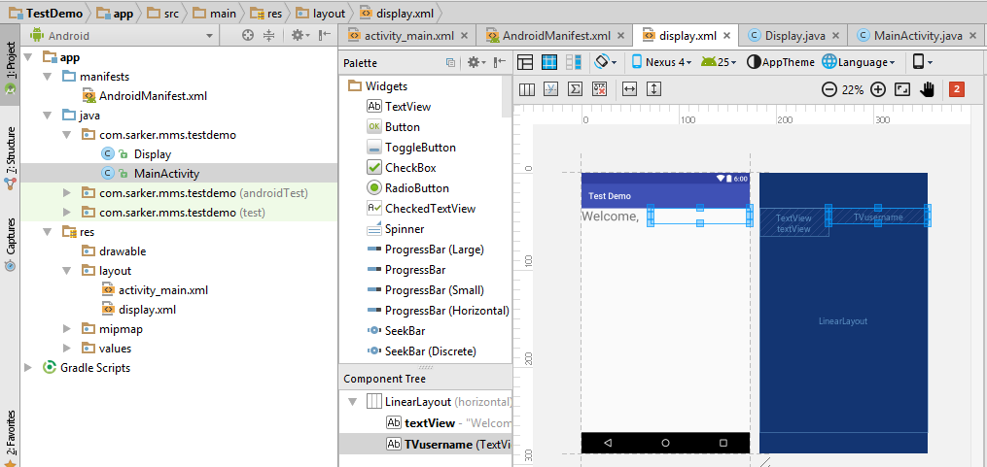

*<?***xml version="1.0" encoding="utf-8"***?>*<**LinearLayoutxmlns:android="http://schemas.android.com/apk/res/android"  
android:layout_width="match_parent"  
android:layout_height="match_parent"**>  
  
<**TextView  
android:text="Welcome, "  
android:textSize="30sp"  
android:layout_width="157dp"  
android:layout_height="65dp"  
android:id="@+id/textView"** />  
  
<**TextView  
android:text="@string/emptyString"  
android:textSize="30sp"  
android:layout_width="wrap_content"  
android:layout_height="wrap_content"  
android:id="@+id/TVusername"  
android:layout_weight="1"** />  
</**LinearLayout**>

**MainActivity.java**

**package** com.sarker.mms.testdemo;  
  
**import** android.content.Intent;  
**import** android.support.v7.app.AppCompatActivity;  
**import** android.os.Bundle;  
**import** android.view.View;  
**import** android.widget.EditText;  
  
**public class** MainActivity**extends** AppCompatActivity {  
  
@Override  
**protected void** onCreate(Bundle savedInstanceState) {  
**super**.onCreate(savedInstanceState);  
setContentView(R.layout.***activity_main***);  
 }  
**public void** onButtonClick(View v)  
 {  
**if**(v.getId()== R.id.***Blogin***)  
 {  
EditText a = (EditText)findViewById(R.id.***TFusername***);  
 String str = a.getText().toString();  
  
  
 Intent i = **new** Intent(MainActivity.**this**,Display.**class**);  
i.putExtra(**"Username"**,str);  
startActivity(i);  
 }  
  
 }  
}

**Display.java**

**package**com.sarker.mms.testdemo;  
  
**import** android.os.Bundle;  
**import** android.support.v7.app.AppCompatActivity;  
**import** android.widget.TextView;  
  
*/**  
 * Created by user on 11/23/2017.  
 */***public class** Display **extends** AppCompatActivity {  
@Override  
**protected void** onCreate(Bundle savedInstanceState) {  
**super**.onCreate(savedInstanceState);  
setContentView(R.layout.***display***);  
 String username = getIntent().getStringExtra(**"Username"**);  
TextViewtv = (TextView)findViewById(R.id.***TVusername***);  
tv.setText(username);  
 }  
  
}

**AndroidManifest.xml**

*<?***xml version="1.0" encoding="utf-8"***?>*<**manifest xmlns:android="http://schemas.android.com/apk/res/android"  
package="com.sarker.mms.testdemo"**>  
  
<**application  
android:allowBackup="true"  
android:icon="@mipmap/ic_launcher"  
android:label="@string/app_name"  
android:supportsRtl="true"  
android:theme="@style/AppTheme"**>  
<**activity android:name=".MainActivity"**>  
<**intent-filter**>  
<**action android:name="android.intent.action.MAIN"** />  
  
<**category android:name="android.intent.category.LAUNCHER"** />  
</**intent-filter**>  
</**activity**>  
<**activity android:name=".Display"**></**activity**>  
</**application**>  
  
</**manifest**>

